Strategic Computing and Communications Technology

Technology Assessment

The Mobile Phone & Wireless Communications

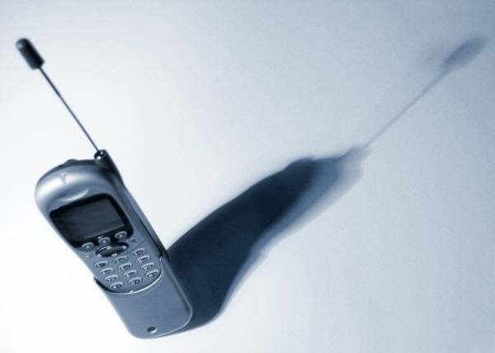

“Worldwide mobile phone shipments soared to 11.7 million units in 2Q05, recording a 288 percent year-over-year increase. PDA shipments exceeded 3.6 million units, up 31.5 percent compared with 2Q04.”
The Gartner Group

Jaime Parada
Ram Rajagopal
Andrew Schultz
Artem Tkachenko
Andres Torrenti Visiedo

1. Introduction

This technology assessment analyzes the mobile phone industry from two different perspectives, business and technology. The keyword in the wireless industry is mobility. Figure 1 shows a simple picture of the wireless access technology space, and how mobility is provided to the final user. The final user connects to a wireless voice/data pipe through one of many devices: cell phones, PDA, laptops, etc. According to CTIA Wireless 2005, over 60% of the US population has a cell phone. The wireless pipe allows the user to connect to direct applications and services, as well as web-based applications and services. In both ends of the pipe (in red), security is provided. In the incoming (left) end, device level security and privacy is offered to the user. In the outgoing (right) end transaction level security is offered to both the pipe owner and the user. The wireless data pipe can be any of different technologies. Just to name a few: Third Generation cellular access provided by commercial carriers; Wi-Fi hotspots provided by vendors and municipalities; Wireless broadband gateways provided by regular broadband internet providers. As the figure shows, in general, both ends of the wireless pipe is populated by users, some who provide services and applications, some who consume these services and applications.

2. Industry Business Overview

The high level view of the value network is shown in Figure 2. We can see that three major groups form the mobile phone and wireless communications space: hardware, applications and service providers. Developments in each group affects every other group. To understand the mobile phone market, we need to understand the business scenario for the other two groups to some extent, and how they interact with our market. In general, pressures from service providers drives new applications and demands on mobile phones. But from time to time, new technologies appear on those spaces and increase the demand of wireless service. We study such effects in detail in what follows.

2.1 The Mobile Communications Value Network

From a more detailed perspective at this industry we can take a look at the wireless space value network. This value network is comprised of four main categories (detail in Figure 3). Each piece of the network shapes the way the whole industry works. They are highly interrelated and even some new technology or a new business model in one part of this value network will have an effect in the way most players operate along this network. It is not unusual that players in the mobile industry are present in two or more categories of the space value network.

Content Aggregation
Service Delivery
Handset Control
Content Generation

2.1.1 Content Generation

In this category, non-mobile specific content generators (even large - CNN and Warner) tend to deal directly with content aggregators rather than operators (For example Yahoo Europe/Mobile 365, Mforma/CBS). In other cases some of the large creators generate mobile content and use aggregators to distribute it (Endemol). However for in this category, multinational content creators and games developers seem to be almost the only viable pure players

2.1.2 Content Aggregation

There has been an expansion process along the value chain to generation and delivery. Most content aggregators cover creation, aggregation and distribution/delivery of content (Opera Telecom, Mobile 365, and Mforma). Many content providers chose content aggregators mainly based on the number of agreements with operators. It appears that a consolidation process among content aggregators is under way

2.1.3 Service Delivery

Most service provision tends to be carried out by content aggregators in this part of the value network. Players that were focusing mainly on delivery platforms are integrating upstream and downstream. The real value in this category will be in promotion and business intelligence. Only a few players have concentrated on content delivery and handset control (Handango, Celltik).

2.1.4 Handset Control

In this area of the wireless space value network, applications and user interface are areas where new players are entering. Smart Card manufacturers are trying to avoid commoditization by controlling the user experience. They are doing this by offering different user interface for manufacturers, controlling content through increased memory and monitoring customer base usage for operators. Device manufacturers aim at counterbalancing the MNO power by developing their own SW (e.g. designing and developing new user interfaces for their devices)

3. Industry Technology Overview

Wireless providers throughout North America, Europe, and Asia are rolling out new high speed data networks hoping to capitalize on new streams of revenue and new avenues of product differentiation. The leader in mobile data services and usage over the past several years has been Japan. Led by the partially state owned NTT DoCoMo, the i-Mode 3G service has had rapid market penetration. In Japan over 72% of wireless users have i-Mode enabled phones [1]. In the US and Europe the adoption of wireless data services has been slower, although simple services like SMS, IM, email, and customization have provide billions of dollars of revenue each. Given the vast potential of data enabled wireless devices, wireless providers are increasingly aware of their roll in both content distribution and creation. Among the wireless providers’ greatest fears is becoming a “dumb pipe” [2] and, therefore, not reaping the benefits of supplying the content they distribute. There are two major markets that are currently growing out of the new high speed data networks. The first, mostly driving the growth in the US, is the business market. The second, driving growth in Europe and Japan, is the personal content market. Each of these two markets has a set of technologies enabling their growth.

3.1 Business Services (US)

In the United States the market for business data services has been a major driver for high speed data networks. To enable this growth US wireless providers have rolled out a variety of medium speed data networks collectively known as 2.5G. These technologies, and their relative speeds are summarized in Figure 4. Still, in 2004, mobile data accounted for just 4.8% of operators' total mobile services revenue in the USA, compared to 15.9% in Western Europe and 22.0% in Japan [11].

The applications most widely utilized in the business data world include e-mail, SMS, and IM. Wireless companies are partnering with IT providers and data centers to expand these basic applications with more full featured solutions including VPN support, database integration, and business productivity applications which integrate with existing Internet SOAs [3]. Wireless providers and software companies have utilized open software platforms such as J2EE to leverage a wide range of existing business applications.

3.2 Personal Services

Even with the relatively low data speeds of existing 2G networks, the potential of personal data services has already been established. Simple data technologies like SMS and IM already have huge usage in the US and Europe, where some 70% of wireless users use SMS to communicate [4]. Personal customization has also provided billions of dollars in revenue for wireless providers and content providers. Customization encompasses small downloads such as ring-tones, wallpapers, and games. To provide a wide variety of personalization content the wireless providers have increasingly sought out partnerships with content providers, and even created content internally. In addition, wireless providers have acknowledge the enormous impact of content provided under well known brand names and have begun content ventures with brand names like Disney and ESPN [5]. Another personal service provided by wireless data communication is mobile commerce. Previously touted as mCommerce or uCommerce [6], the goal is to allow wireless devices to act as payment instruments for small transactions. This technology has been hyped for several years as the next big thing in wireless services, but as yet still remains relatively small scale. However, as more users adopt wireless data services through usage patterns like personalization and entertainment, commerce services will become increasingly easy to adopt.

3.3 Software Platforms

As cell phone handsets become increasingly sophisticated, the software platforms which run on them have increased in sophistication as well. The most popular platforms have been those that are built on J2EE, PalmOS, and SymbianOS which allow third party developers to create games and applications for the phones. This strategy is similar to that found on the Internet, where opening up an API and allowing users and third parties to create the applications has been extremely profitable. Most cell phones also support Java’s application framework which allows games to be rapidly developed by third parties and used on a wide range of handsets.[7] Multi-function and specialized wireless devices are also becoming increasingly popular. Apple recently teamed with Motorola to release a special edition cell phone that can interoperate with Apple’s iTunes online music service. Nokia has released several versions of its N-Gage gaming device which not only plays single player games but uses the network to allow multiplayer gaming.

3.4 Mobile Devices

Cell phones today are essentially battery-powered microprocessors with one or more wireless transmitters and receivers optimized for voice I/O. They provide a keyboard, an LCD screen, and a general-purpose computing platform, typically supporting Java2 Mobile Edition API. More sophisticated models provide a camera, 1MB-5GB of local storage, a full-color screen, multiple wireless interfaces, and even a QWERTY keypad. Nearly all cell phones today provide voice and data I/O over either CDMA or GPRS networks.

Even thought voice is still the killer application, revenue margins are moving from voice-centric cell phone usage to the data-centric one. CDMA/GSM is expected to continue its dominance (Figure 5) and is the underlying technology for 3G rollout [8]. 3G has been deployed 70 countries worldwide (Figure 6) and is supported by 158 commercial operators [9]. Cell phones have overtaken fixed-line phones for voice transport because people are willing to compromise on quality and cost to gain mobile access.

Given that voice revenue has wafer thin margins, there is a huge financial incentive to roll out innovative data services rapidly. For example, NTT DoCoMo subscribers use data services at up to 384 Kbps, which are achievable with 3G technology, to access video clips, upload camera images, and get street maps, stock quotes, restaurant menus, weather, and ‘yellow pages’ information [10].

Due to the large user population, costs shrink dramatically, both for handsets and for service. Handsets are already manufactured in the hundreds of millions every year, which makes it possible to dedicate expensive chip fabrications and ASIC developers to the task. These up-front capital investments have greatly reduced the marginal cost per handset (Figure 7). Similarly, large volumes allow service providers to make healthy profits with small markups, reducing the price of service.

Device convergence is a reality with cellular enabled PDAs and cell phones that play MP3s. In most cases, a brand name from the respective industry (PDAs or MP3 players) associates with a handset company, such as Motorola. 16% of European mobile phones already have in built cameras, and the number is steadily growing (Figure 7 and 8). Currently, there are about four times more (300 million) digital photo enabled cell phones deployed than digital cameras.

Still, surveys point out that only about 6% of US users consider the ability to take and receive pictures an important cell phone feature [13]. Small size, color screens and polyphonic ringtones are considered more important. Still, we see that devices are already experiencing a convergence phenomena, with phones tailored for various functionalities such as 7 Mega Pixel camera phones and game oriented phones.
4. Business and Technology Trends and Forecasts

In this section, we look into more detail on how current and future tendencies are shaping the interplay between the value chain, devices and applications for wireless. We also qualify which kinds of submarkets and companies will be best positioned for the coming years in this market. A summary by player is shown in the Appendix.

4.1 Commoditization of Voice Services and the Drive towards Consolidation

The cellular market has been under continuous pressure towards horizontal consolidation. In recent years, we have seen Verizon acquire or merge with Bell Atlantic Mobile, GTE and Airtouch/Vodafone and Cingular acquire or merge with SBC, Bell South and AT&T Wireless and Sprint with Nextel. 4 National Players remain: Sprint, Verizon, Cingular and Deutsche Telecom (via acquisition of VoiceStream’s network). Vodafone and NTT Docomo are penetrating the US market, being global leaders.

The main drivers are the economy of scale obtained by having more users under a single network and commoditization of voice services. Local radio deployment and operation costs remain largely fixed, even if a company doubles its number of subscribers. Furthermore, a large base of subscribers increases the bargaining power of a cellular service provider with hardware companies, such as Motorola, with government regulators, with application service providers and with retailers as well.

Most cellular service providers are betting in the capability to offer reliable and high availability data transport services over their current voice networks. Third Generation (3G) deployments are mainly aimed at improving the quality of service and the offerings in data transport to the end user. Still, the current rates are low for more sophisticated services such as live video and streaming. Thus, ever increasing spectrum hunger is also an important driver towards consolidation as well as technology development. Companies that develop multiple antenna access and/or shared spectrum (Spider) technologies will gain momentum in the near future.

With this consolidation in the cellular space, one considerable technical challenge has appeared: the integration of overlapping networks. Very few successful network interlacing examples are currently known. In addition, configuring a network to run seamlessly using switches from different vendors, as well as multiple legacy customer databases, subscriber authentication systems, and billing platforms, poses a daunting challenge. So expect to see companies that offer such integration and “rewiring” services to succeed in the short to medium term.

4.2 Alternate Wireless Access Threat

Alternative access points to the wireless data pipe are quickly becoming popular (Figure 10). The most popular alternative is a Wi-Fi hotspot. A Wi-Fi hotspot is a wireless connection to an internet port, using the IEEE802.11g protocol. For example, a wireless router connected to a local home broadband gateway provides such connectivity at home. About 20% of US homes with a broadband gateway have a wireless LAN setup. In a conservative estimate, ABI predicts worldwide hotspots will grow in the next five years from 28,500 to 208,000. The municipalities of San Francisco and Philadelphia are planning to setup municipal wireless access to the web, to permit affordable connectivity to the city residents. New York City boasts several hotspots by Verizon and T-Mobile.

Cost of access is still being defined. Right now, most of the hotspots require users to pay for access, either through a subscription (perhaps $30 to $40 per month) or on a one-time basis ($7 for 24 hours, for example). Prices are going down drastically, and companies are making agreements with each other so that a user can use alternate hotspots as he moves around. Sharing the infrastructure is much simpler under this technology. In fact, if hotspots are pervasive enough they might even provide viable and very cheap alternatives to wireless voice access, by allowing users to use voice via Voice-Over-IP technologies.
As wireless hotspots become more pervasive and we also observe a convergence of wireless devices, they become an alternative to 3G cellular data access technologies. The main advantage of hotspot access technology being that a much higher data rate is obtainable today for a fraction of the cost. 10MBps access points are quite common. This is a rate still very far from that offered by cellular data access. On the other hand cellular data access is available anywhere, anytime. Furthermore, most cellular companies are starting to setup and offer hotspots.
Most likely, a scenario of coexistence, with high speed hotspots complemented by anywhere-anytime 3G/4G access will result from the current tendencies. Costs will play a major role. Wireless access is quickly becoming a commodity like water or electricity, so cellular service providers will need differentiated data services to lure customers and remain profitable. The survival of phone device manufacturers is directly linked to their capability of exploiting high data rate services through the cell phone, creating hybrids between cell phones and other devices such as PDAs as well as forming alliances with other parts of the value chain (for example, content aggregation).

4.3 Development of a User-Centric Wireless Space

The most popular non-voice services for cellular customers right now are the use of SMS text messages and the purchase of screensavers and ringtones (Figure 11). The worldwide sales of ringtones alone surpass 2 billion dollars and has a huge growth perspective. The growth and frequent use of these services shows a move towards a user-centric wireless space. If in a first phase of wireless deployment, service availability and cost were the main drivers, now user preferences and customization availability become very important factors as well.

The first important characteristic of a user centric wireless space is that it offers personalization: the capability of the user to personalize his cellphone, as well as personalize his data access and views. Beyond ringtones and cellphone screen savers, companies are looking towards offering the user the capability to configure and personalize cellphone accessible web news (mainly weather and sports) and even storefront and one click purchase offerings (for example, NTT Docomo in Japan plans to offer a one click sale of video snippets of baseball scores).

A second characteristic is to offer localization based services. Broad localization based services are desired by 62% of Japanese users by allowing selected companies to access your location. The proportions are 52% in the UK, 42% in Germany and 36% in the US. It is clear that in markets where users are more inclined to use advanced services, there is a desire to have localized services. Some examples are localized search for information and price comparison. Localization based rescue information services are being setup by some states, such as New York. Localization information directories and guides, such as in national parks, museums and football stadiums, will also become quite common in the future.

The widespread use of SMS text messages around the world, show a tendency for users to divide wireless communication services into two distinct categories: immediate communication (such as calling another using and interrupting him) and non-intrusive communication (such as SMS text messages). Thus a user centric wireless space should be able to provide non-intrusive communication capabilities for the user as well as for application providers. One example is to offer opportunistic sales technologies based on localization. One would desire alternative prices for products, when inside a shopping, but only for those products being shopped for. As search engine ads have become non-intrusive, opportunistic sale points, for the web, we expect that such capabilities are developed for the wireless space.

A user centric wireless space provides the user with information anywhere, any time, anyplace and in any device. The infrastructure developments will be complemented with application and technology development to support such a space. Most specialists are convinced that most future revenues from the wireless space will come from user centric services. Companies that offer such know how and development tools that support these ideas for application providers are poised for major growth.

4.4 Security

As the exchange of information and applications for wireless use become pervasive, security becomes an essential concern. The ability to have information privacy and secure information exchanges is essential for a host ofservices. Figure 1 shows that both end points of the wireless pipe need secure information barriers. In the incoming side, the need is for protecting the information of a single user from being viewed by the users, thus providing a secure user centric space. In the outgoing end, the information exchanges between users or their cellphone service carriers and applications behind the web should be secured from other web users. Such security is essential if commercial transactions will be carried out by users using mobile devices. Another typical application that is heavily dependent on security is the access of business related critical information by users anywhere, anyplace.

Furthermore, wireless spam will also become a concern. The ability of a user to have a protected personal wireless space will determine if wireless technologies will become an effective option for commercial and other applications, or if they will turn out to be just one more annoyance, such as e-mail sales offers have become. Lots of investment in secure standards, such as IEEE802.11i with encryption for hotspot access, and security barrier technologies are currently being made.

It is expected that more than 50% of the American companies will offer wireless lan and wireless data access by the end of 2005 [12]. In 2001, the European wireless security revenue was already more than 10% of the total applications infrastructure revenue of about US$1 billion. If the developments of the web are any guidelines, we can expect a boost in such expenditures and in this market. Companies that provide technologies for securing wireless user spaces, tools for developing secure wireless applications and know how to setup secure wireless infrastructures for other business are going to benefit the most from this trend. For cellphone manufacturers, including advanced security management at the device level will be an important feature.

4.5 Convergence of Devices and the Application Centric View

Access is important, not necessarily the means of access. This idea is becoming reality as we observe the convergence of devices in mobile space. From a variety of options, we are seeing more and more the convergence to two or three choices: laptops, supercharged cellphones (with video and audio displaying and recording capabilities) and palmtop computing devices.

In the long run, it is expected that cell phones will be dominant over PDAs and laptops in the mobile space (e.g. reading e-mail in the elevator). Beyond the right form factor, cell phones enjoy cost subsidy and market size benefits not available to the other two options. Dockable devices with large local storage will allow users to carry all their data with them all the time providing data and compute mobility, with multiple connectivity choices from CDMA/GSM to WiFi/Bluetooth. Demand for highe bandwidths and low costs will lead to WiFi enabled cell phones that can seamlessly switch to WiFi when available. This will require cell phone manufacturers to either build out or partner with WiFi providers.

The applications space will further dictate the revenues of most players (Figure 9) in the wireless arena. Devices that have intuitive interfaces, together with application providers offering interesting on-demand services such as toll paying from your cell phone, downloading a touchdown video from the live NFL final, upstreaming an hour personal video shoot, automated medical monitoring and rapid emergency response systems. Transforming the cell phone into viable entertainment platforms by offering larger thin screens (with new LCD technologies), more convenient gamming options and MPEG4 playback with long battery life, are the most promising consumer technologies in the short term.

If providers, developers and device manufacturers can provide a seamless wireless workspace, with secure transactions and a usable intuitive user interface, then the wireless data access industry will experience a boom, going beyond hotspot and network connectivity. There will be demand for “always connected” services. So expect to see more of device manufacturers moving up the value chain.

A. Bibliography

[1] Use of Wireless: Global and North American View”, Jean Barrette, Bell Mobility Investments, October, 2002.
[2]“Next Generation Wireless Data for Consumers”, AlwaysOn.com, February, 2005.
[3] “US 2.5G and 3G Business Services”, Lisa Pierce, Forrester Research, January, 2005.
[4] “Europe’s Mobile Consumer Technographics”, Christof Herzog, Forrester, June, 2005
[5] “Next Generation Wireless Data for Consumers”, AlwaysOn.com, February, 2005.
[6]“The Future of Wireless: Different than You Think, Bolder than You Imagine”, Accenture Institute for Strategic Change, May, 2001.
[7]“Games and Entertainment Within the Mobile Phone Industry”, Gartner Research, April, 2002.
[8] Instat at www.instat.com
[9]3G today at www.3gtoday.com
[10]”Why Cell Phones Will Dominate the Future Internet”, S. Keshav, 2005
[11] Mobile Media News, 10/28/2005
[12] Business Week, March 2002
[13] Mobile Monday, 2004
[14] Mobile Imaging Summit at http://www.mobileimagingsummit.com/
[15] “Not Just Talk: 3G CDMA”, P. Jacobs, September 2005

B. Appendix: Summary of future tendencies by player

B.1 Mobile Network Operators

- Declining revenues for voice services are showing a commoditization of such access
- Potential technology threats like VoIP together with free and universal WiFi access and virtualization
- Network Connectivity &Data Transmission, data services to boost revenues: desperately looking for a ‘killer application’ that boosts Average Revenue per Unit
- Future strategies of consolidation, global operators and service bundling: conglomerates.

B.2 Broadcast and platforms providers

- Platform providers have either not reached profitability or have only recently reached profitability
- They seem to focus on content optimization and adaptation for mobile network operators
- Are increasingly getting involved with content management by aggregating content from multiple sources. They may ultimately want to manage the entire content delivery chain for MNOs using their platform solutions

B.3 Device Manufacturers
- Long-term trends may indicate that handsets may become commodity products just like hardware in the computer industry
- As a result, handset leaders could start exploiting current capabilities to expand to other areas of the value chain.
- For example, Sony Ericsson is positioning in the content aggregation market to appropriate value. This could pose partnership opportunities for Celltick with Sony Ericsson.

B.4 SIM Manufacturers
- Strong cash flows, investor base and diverse clients
- Trend towards commoditization unless players shift in the value chain. For example, SIM manufacturers are developing an enhanced user interface for SIM based services, which pose a direct threat to Celltick’s Livescreen
  - Gemplus developed GemXplore, a new range of SmartCards that enhances the user interface for SIM based services

B.5 Users Interface Experts

- UI companies aim to increase subscriber awareness of data through push/pull strategies and by making the migration more intuitive for subscribers
- They have not only internal competition, but also face tough competition from leading device manufacturers and even some wireless operators

C. Figures



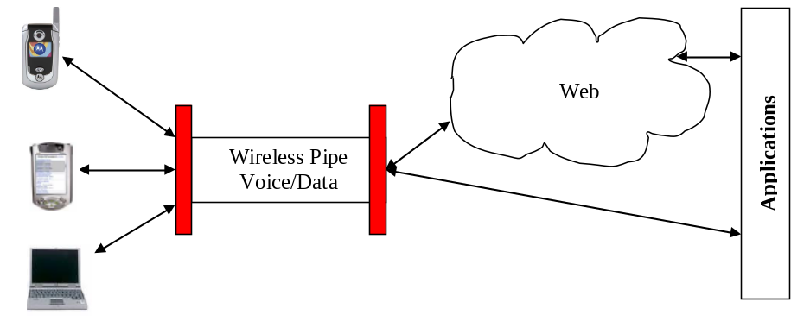
Wi-Fi Hotspots
Broadband Gateways
3G Technology

Figure 1: The wireless space

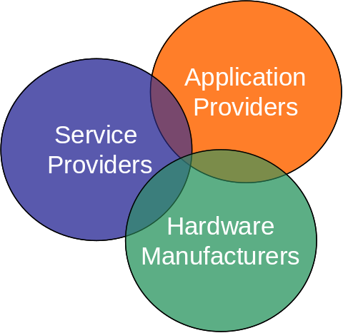
Motorola
Sim card companies
Apple
ESPN news
Payment services
Mobile1ringtones
Games
Apple (I-Tunes)
Cingular
Verizon
T-Mobile
Sprint
Motorola ROKR
Figure 2: High Level View of the Value Network
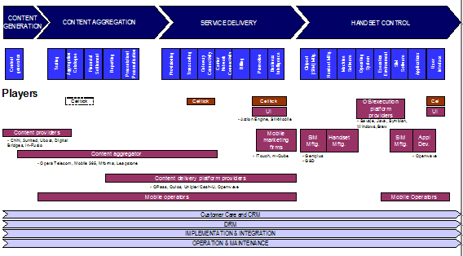
Figure 3: Wireless Phone Value Network

Technology | Bandwidth | Prior Technology | Voice/Data Capability | Provider
GPRS | 20 – 40 Kbps | GSM | Data | Cingular
EDGE | 90 – 135 Kbps | GSM | Data | Cingular
UMTS | 150 – 250 Kbps | CDMA | Both | Cingular
1XRTT | 60 – 80 Kbps | CDMA | Data | Verizon, Sprint
EVDO | 300 – 500 Kbps | CDMA | Data | Verizon, Sprint
EVDV | 300 – 600 Kbps | CDMA | Both | Verizon, Sprint
Figure 4: Mobile technologies data rates [3]

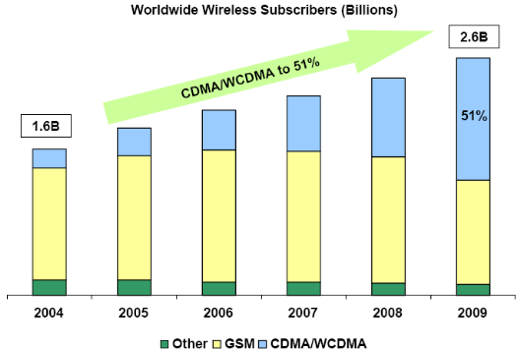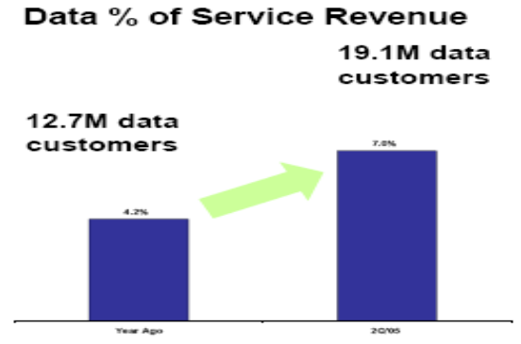

Figure 5: CDMA/GSM market share and Verizon Wireless data users [15]

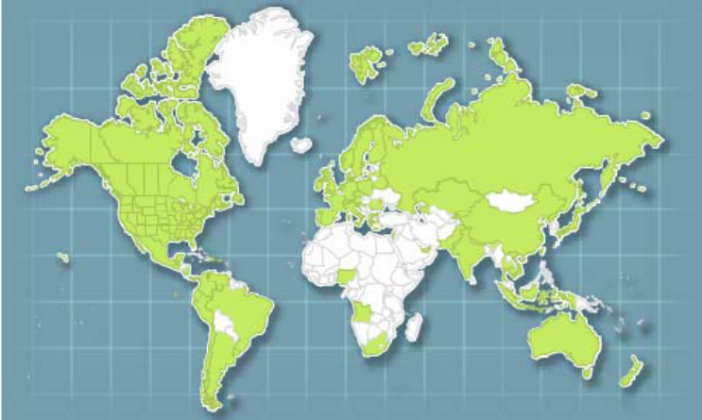
Figure 6: 3G Coverage (in green) [15]

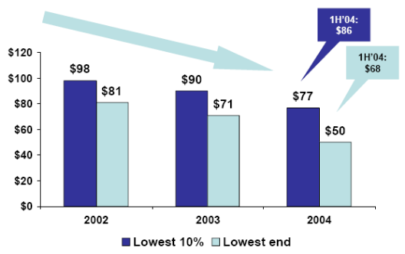
Figure 7: Wireless Phone Value Network [15]

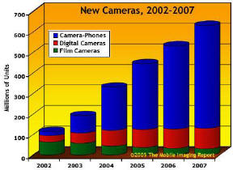
Figure 8: Camera Phone sales, compared to regular digital cameras [14]
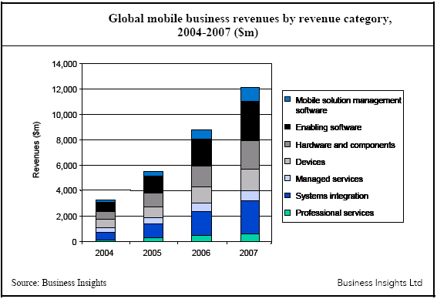
Figure 9: Mobile business revenues by category
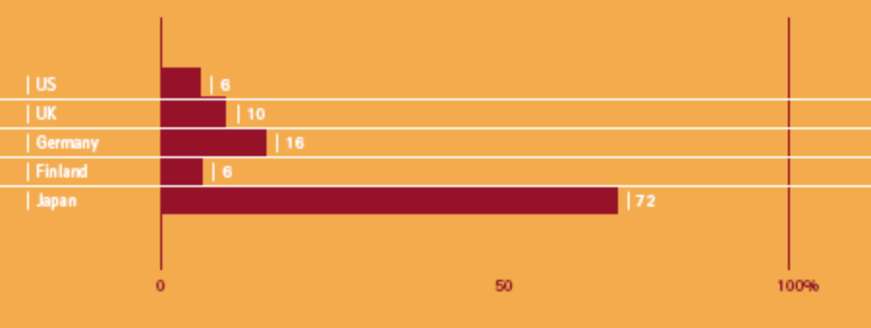
Figure 10: Percentage of users who use their cellphone to access the internet out of the universe of cellphone users [6]

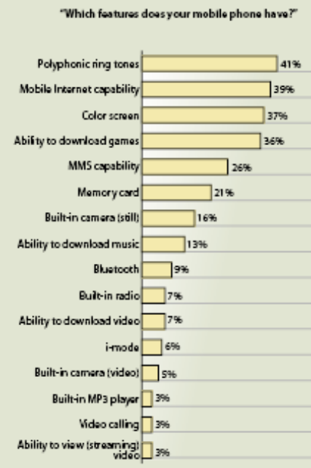
Market | Ringtone sales (US$ billions)
US | 0.3
Western Europe | 1.5
Korea | 0.5
Rest of World | 0.7
(a) (b)
Figure 11: (a) European preferences for mobile phone features [12] (b) Revenues of ringtone sales [13]

